**Section 2–4B: Application of Linear Equations**

**Example: Drawing and Interpreting a Linear Graph**

**BIOLOGY:** the number of times a cricket chirps per minute depends on the temperature. The numbers of chirps in 2 seconds for two temperatures are shown here,

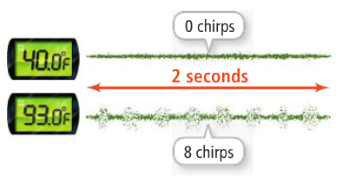

1. **What graph models the situation?**

First, you need to find the number of chirps per minute – because there are 8 chirps for every 2 seconds, so you need to multiply **30** in order to know the chirps per minute.

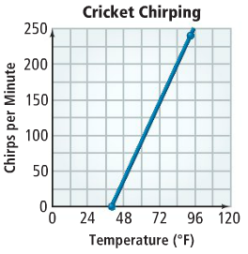 $40℉:30\left(0\right)=0$

$93℉:30\left(8\right)=240$

Let *x* = temperature in degrees Fahrenheit.

Let *y* = number of times a cricket chirps.

Plot $(40, 0)$ and $(93, 240)$.

Now draw a line through the points.

1. **What is an equation of the line in standard form?**

Start with the slope formula: $m=\frac{y_{2}-y_{1}}{x_{2}-x_{1}}=\frac{240-0}{93-40}=\frac{240}{53}≈4.5$

Use the point-slope form: $y-y_{1}=m\left(x-x_{1}\right)$ Substitute one of the points: $(40, 0)$.

$y-0=4.5(x-40)$ Simplify.

$y=4.5x-180$ Write in standard form.

$4.5x-y=180$

1. **If the temperature is $70℉$, how many times would a cricket be expected to chirp in one minute?**

Let $x=70$.

Use the equation from part (b): $y=4.5x-180$ Substitute.

$y=4.5\left(70\right)-180$ Simplify.

$y=135$

If the temperature is $70℉$, the cricket would be expected to chirp **135 times** in one minute.